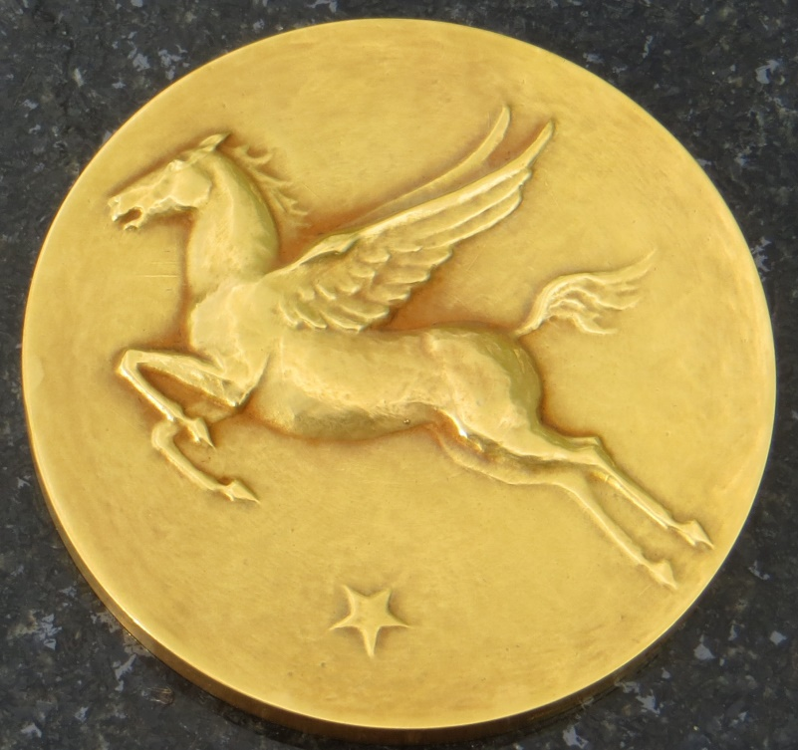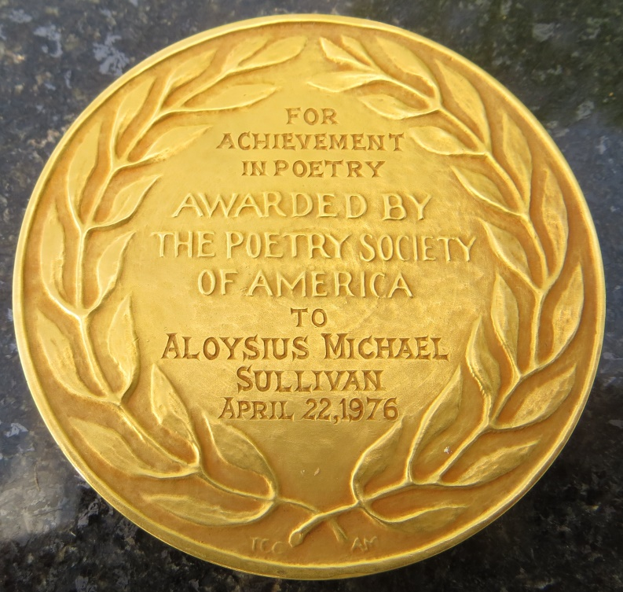
In 1976, A.M. Sullivan was awarded the Poetry Society of America’s highest award, known as the Frost Medal, named so for Robert Frost, who received the award in 1941. This award honored Sullivan for his lifetime contributions to American poetry.
For a list of Frost Medal recipients, see:
http://www.poetrysociety.org/psa/awards/frost_and_shelley/frost_winners/

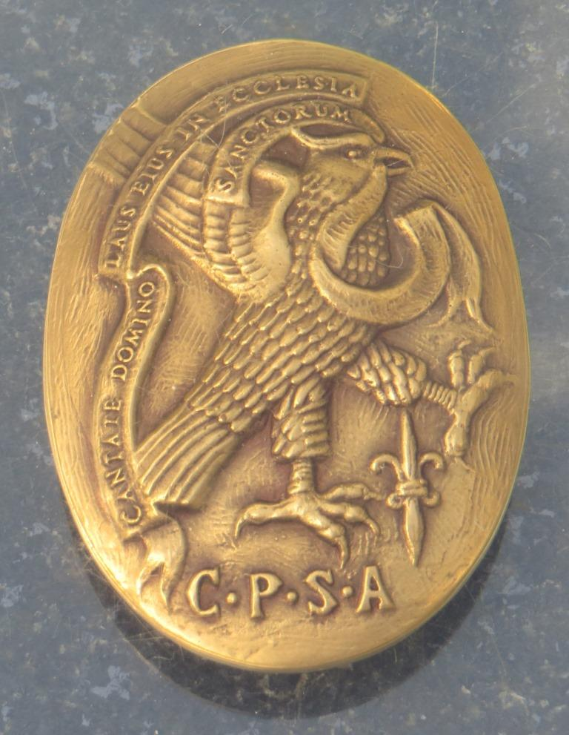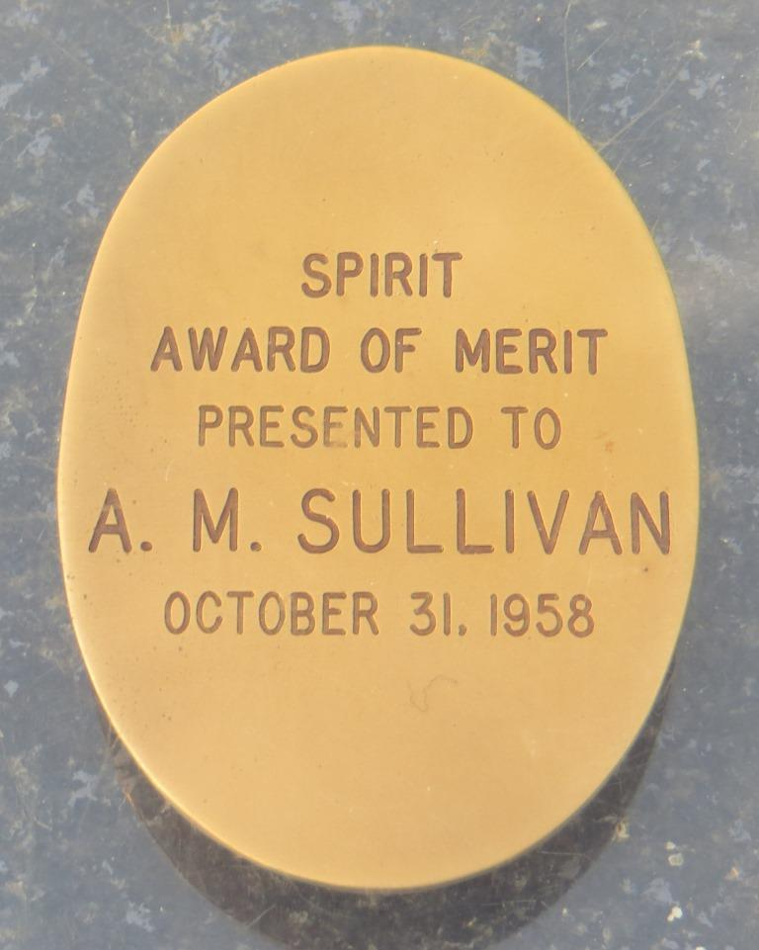

In 1958, the Catholic Poetry Society of America awarded A.M. Sullivan the Spirit Award of Merit. Spirit is the society’s magazine of poetry. No information about this award available online.
Sullivan received other awards for his work, including the Alexander Droushkoy Memorial Award. He was also medaled by the King of Denmark for support against the Nazis in World War II. See: “Fightin’Nazis” on the main page.

